
Marldon’s School Report  School: London Fields Primary School  Presentation Date: 19th September 2016  Presentation: Tree Talk and Patio size Apple tree presentation  Our Environmental Consultant Lara Ayris was delighted to present a patio sized Apple Tree [Malus Pumila] (size requested) to Rebecca Brown of London Fields Primary School, accompanied by a boisterous group of 4 and 5 year olds from London Fields.  They were a bubbly group who showed a lot of interest in the reasons why the tree was being donated. The presentation took place in their BIO-dome, where the apple tree is going to have a central position. The tree even had a few apples on it, which delighted the children.  Lara made a simple presentation about trees and why they are important to our world was given, because the audience was so young. She also explained how the construction industry can help with environmental issues and why Marldon are donating this tree. .  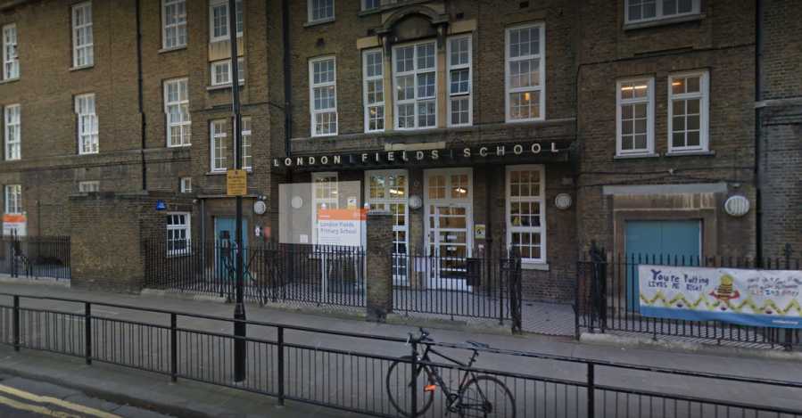 | 