**Prescot House, 31-33 Prescot Street, London E1 8BB**

**and 99 Mansell Street, London E1 8AX**

**Construction Management and Logistics Plan**

**Prepared by**

**Marldon**

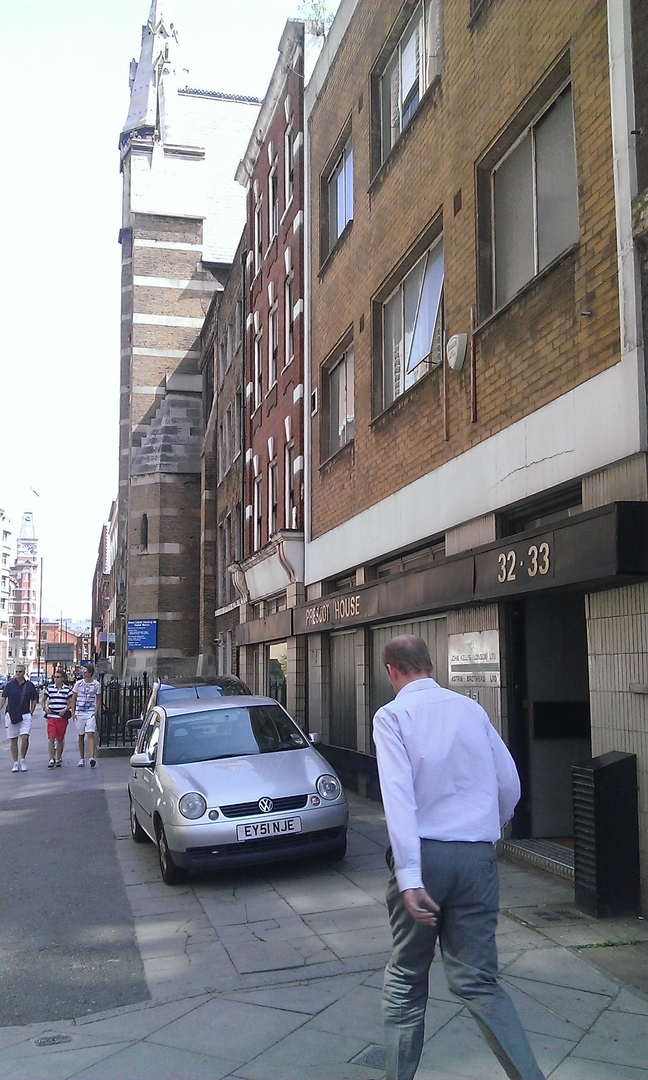

**PART 1 : THE SCHEME**

**Introduction**

This document has been developed to explain how Marldon as developer and contractor intend to manage the construction and logistics for the development of 31-33 Prescot Street and 99 Mansell Street.

The site consists of 3 existing buildings of varying height:

* 31 Prescot Street, an early Victorian building has 4 storeys plus basement
* 32-33 Prescot Street, a reinforced concrete post-war building with 3 storeys plus basement
* 99 Mansell Street is a 6 storey plus basement brick, steel and timber and reinforced concrete building.
* The buildings on Prescot Street have been demolished down to basement level.

**Project Description**

The works comprise of the demolition of the existing buildings and the future construction of a new building. These include:

* Soft strip out and removal of asbestos containing materials;
* Disconnection and isolation of all existing main services to the building
* Demolition of the existing 3 buildings down to ground level (31-33 Prescot Street has been demolished), retaining the existing basement level, the existing basement will be slightly enlarged to the rear;
* Groundworks including piled foundations;
* Construction of new 5, 7 and 10 floor reinforced concrete building with new larger basement;
* Internal fit out works to form new office space and apartments.

Marldon already have planning permission to build 31-33 Prescot Street as a separate scheme and are now preparing a planning submission for the combined site incorporating 31-33 Prescot Street and 99 Mansell Street.

**Overview of Site**

The site is located on the western fringe of Tower Hamlets on the boundary with the City of London in close proximity to the River Thames, the Tower of London and lies between Aldgate and Tower Hill. The B126 Prescot Street is a one way dual carriageway which feeds in to the major Aldgate gyratory system.

99 Mansell Street is situated on the corner of the junction with the Minories and Mansell Street; 31- 33 Prescot Street is next door to it, to the east. East of this, the existing buildings on 31–33 Prescot Street are adjoined by a terraced Georgian house; the site is enclosed to the rear [South] and to the west by other properties. The primary elevations are the front elevations on Prescot Street to the North and Mansell Street to the North West, which both open on to the pavement.

There is a small area of pavement belonging to the development in front of / north of Prescot Street [‘the forecourt’] which has been used historically for parking vehicles by previous owners.

The properties enclosing the site share boundaries with the site. To the south of the building are two railway arches, used by a small business, Barneys Seafood Ltd, who are wholesale fishmongers to the restuaramnt trade.

The arches support a disused railway line which curls around the site from the south to the west and encloses the rear of the entire site, ending adjacent to the south west elevation of Mansell Street. The section of disused railway joins up with another raised structure with a major over-ground & operational railway line; there are disused cabins here, one of which houses a major power cable and fuse board for the working railway. The railway line itself is in fairly close proximity to the site boundary but the disused part of the railway and the inhabited arches are the immediate neighbours.

To the east of the site is No 30 Prescot Street, a presbytery and residence for the priests serving the Roman Catholic Church of the English Martyrs which is directly adjacent to No30. There is a crypt underneath the church, rented out to a nightclub/bar.

To the north and across Prescot Street is Londinium Towers a mansion block with 87 residential apartments with a Wetherspoon’s pub at ground floor level. Next to it, across a side road, is the Grange Tower Bridge Hotel.

Below is the red line drawing showing the site boundaries and the confinements of the site.

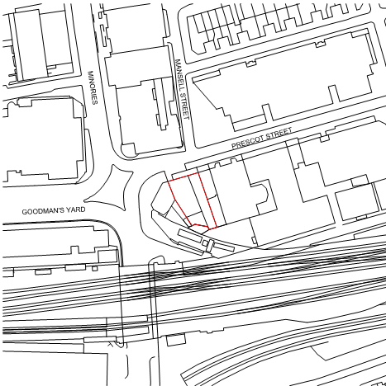

**Access & Logistics Issues:**

1. Public movement along Prescot Street.
2. Building occupants movement to surrounding buildings.
3. Other deliveries and vehicle movement on surrounding roads, especially to the hotel opposite.
4. Church meetings and congregations.
5. Prescot Street being a one way street.
6. Traffic lights at the junction with Minories and Mansell Street with traffic backing up past the site.
7. Prescot Street being a red route.
8. Cycle lane on pavement to front of Mansell Street.
9. Network Rail to the rear.

**Details of Developer & Principal Contractor**

Marldon

3 Scouts Lane

Clapham Old Town

London SW4 0LA

**Site Location**

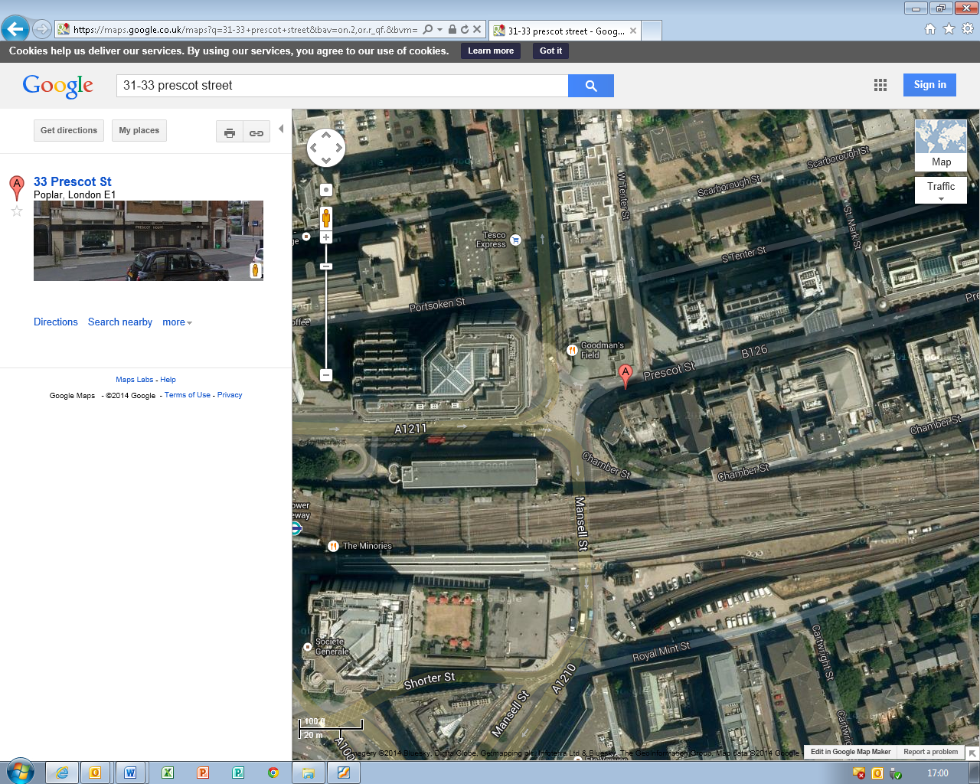

**Roadways**

The site is situated on the corner of the junction with the Minories and Mansell Street; this junction is controlled by traffic lights, which leads to a buildup of traffic to the front of the site.

The property is not listed, however the adjoining property to the east and the Church adjacent are both Grade II listed buildings.

# Directly to the front of the building is an area which forms part of the title. It is used as a forecourt car park this is accessed via an existing crossover off Prescot Street.

**Neighbours**

Marldon take their duties towards their neighbours very seriously. The protection of the Presbytery at No30 is essential as it is a listed building; the disruption to the priests is to be kept to a minimum throughout.

Prior to commencing demolition works, the adjoining wall of No 30 is to be supported and tied back to ensure the stability of the building, by formal agreement with the priests and their advisors. These works will be carried out in accordance with the temporary works designers design and risk assessment and method statement.

The scaffold will be designed by a specialist temporary works designer and will be designed to provide protection to No 30 and the building to the rear at all times.

For complete details of this element refer to the demolition risk assessment and method statement, scaffold design and formwork risk assessment and method statement.

Adjacent and to the rear of 99 Mansell Street is the Network Rail-owned land, occupied by Barney’s Seafood; Barney’s hours of work are 2am – 12.30pm. The works will not have such a direct effect upon the business as there is no access required from this side; however Marldon are to keep him informed of any noise and disturbance. Network Rail are to be contacted and all information relating to the demolition and construction as it affects them must be issued to them for review and comments.

Scaffolding will be erected to the entirety of the development once it is erected past the 4th floor, as per the temporary works scaffolding design.

Fans will be installed additionally over Prescot house and Network Rail land to prevent the falling of material.

Scaffold to all elevations will be fully enclosed with monoflex, preventing the spread of dirt and debris outside of the site.

Works will be carried out to ensure as little disruption to neighbours as possible. Marldon will keep in continuous contact with the neighbours to keep them aware of progress and upcoming activities.

**Consultation**

Consultation with neighbours will be via regular newsletters/emails, advising them of the status of the works, and any upcoming activities or issues that may affect them. These will be posted to neighbours prior to commencing and then regularly throughout the project.

Close consultation with the church will be maintained throughout the construction works, keeping them updated on progress and activities that may cause a disturbance.

The site management team will also make personal contact with the neighbours to introduce themselves and provide details of who they should contact if they have any concerns.

There will be a nominated person on site who will be the main point of contact with neighbours and the public and will deal with and record any comments, complaints or compliments - this will be recorded in the on-site log book and reviewed regularly by site management.

**Public Realm/Pedestrian Movement/Vehicle Movement**

The building has only the one frontage onto Prescot Street and Mansell Street, on the North and West elevations.

The proximity of the live services to the railway mentioned above is such that Marldon has decided that this precludes the use of a tower crane. Marldon have looked at the logistics to avoid all mobile crane services as well to minimise disruption to the movement of vehicles and pedestrians on Prescot Street.

During demolition, scaffolding and hoists will therefore be required to the front and rear elevations.

Scaffold will also be required for high level construction works, erected within the building boundary line except where it borders the Network Rail land and except where it attaches to the frontage of Mansell Street. It is proposed that this is behind a hoarding – see later.

It is to be recognised that Prescot Street is a very busy street in terms of vehicular and pedestrian movement, especially between the hours of 7am and 10am and 3pm to 8pm.

Marldon will need to service the site with delivery by vehicles and waste removals; we therefore propose to restrict the visits of these construction vehicles to site to between 10am and 3pm, wherever possible, to minimise the effect upon the public.

These will deliver to the site from the forecourt. The proposed logistics for demolition and construction is explained later in this document, which will be issued to and discussed with the Tower Hamlets and TFL to ensure that all issues have been considered and considered.

Construction vehicles will therefore be required to pass over the public footpath on the existing crossover.

To ensure the safety of the public during these times, site operatives will be present to control public and vehicle movement.

At all times during this activity, pedestrian movement will be controlled by site operatives to ensure they are not put at risk from the movement of materials.

Due to the restraints of Prescot Street, removals/deliveries will be organised and planned 24 hours in advance and will be arranged in accordance with the LA and TFL restrictions.

There will be no on-site parking allowed by operatives. All the workforce cycle or travel by public transport to site.

**Site Accommodation and Welfare**

Site accommodation and welfare must be provided to cater for up to 40 operatives. Initially site accommodation will be located within Mansell Street, moved around within the building to allow the strip out to continue. Toilets will be provided which will cover 5 cubicles, one of which will be a dedicated ladies toilet.

On completion of the strip out and prior to commencement of Mansell Street demolition, we propose to site the site accommodation to the front of Mansell Street within serviced containers. For details of locations please see attached site layout plan at the end of this document.

The containers will be stacked as possible to provide the required accommodation. At least one of these will provide a canteen area for the men, one a site office and meeting room, and a smaller one to be used as a drying room and wc facilities.

These wc facilities will be a single toilet unit catering for 40 operatives positioned and connected to the existing facilities from Mansell Street, which will be maintained during the works.

All these areas would require containment within a hoarded off area on the public footway, which requires agreement in advance with TFL and the LA.

Dedicated access towers will be installed to allow access to the upper levels.

**Demolition**

31-33 Prescot Street is a mix of 4 and 3 storey height buildings consisting of lower ground, ground and 3/2 upper floors built with a mixture of concrete frame and walls, brick façade and flat roof.

99 Mansell Street is a 6 storey building consisting of lower ground, ground and 4 upper floors constructed of reinforced concrete on the lower levels and timber frame on the upper.

A refurbishment and demolition asbestos survey has been carried out, which identified asbestos containing materials as being present, all of which has been removed as required under current legislation.

The existing structures will be demolished down to basement level utilising a mixture of techniques including hand and mechanical demolition.

Prescot Street has been demolished down to basement level, with all material removed, Mansell Street is to be demolished which will be undertaken by a specialist and competent demolition contractor. A copy of the demolition risk assessment and method statement will be attached to this management statement.

Mansell Street will be demolished by hand down to first floor then the lower floors will be demolished with the use of an excavator. Material will be removed from the upper floors by way of rubbish chute that will lead to the ground floor, from there it will be removed via the loading bay to the front of Prescot Street.

Noise and dust will be controlled at source, damping down procedures will be used to prevent the spread of dust to surrounding areas, noisy operations will be restricted as laid out by LA requirements with the machinery used having silencers installed.

A detailed risk assessment and method statement will be prepared for the demolition/strip out works which will explain the detailed process to be followed. This will be able to be viewed on site by request.

Wherever possible materials removed will be reused on site within the new construction works, or recycled.

**Construction**

Construction works include piling for foundations, construction of new reinforced structure ranging from 5 to 10 floors with a mixture of brick and rain screen cladding.

There will be a large combined basement providing office space, storage, waste bin area and bike store.

The basement and foundations will be piled, access for the pile machine will be via the existing crossover and then a ramp built of waste material, once the piling is complete the basement slab will be poured.

A static concrete pump will be positioned in the loading bay at ground floor level with pipes allowing the movement of concrete to the required areas.

The reinforced structure will be formed using aluminum formwork. The columns will be formed and poured on each floor followed by the construction of the slab ready for pour. Access to height for the formwork will be via towers; edge protection will be installed to the formwork to prevent falls.

A detailed risk assessment and method statement will be prepared for the erection of the formwork.

A static pump will be utilisied throughout the construction works, positioned at the end of the loading bay adjacent to No30. A rigid pipe will be installed which will run to the core and then be extended up the core as the floors are added.

The external facades will be a mixture of traditional brickwork, brick cladding panels, rainscreen and full height glazing elements.

The roof construction will be flat, reinforced concrete and a proprietary waterproof membrane, plant will be located both on lower level roof spaces and within basement areas.

**Hours of Operation**

Normal working hours will be as the stated times for the local authority which is usually 0730 -1800 Monday to Friday and 0800 – 1300 on a Saturday, there will be no working Sundays or Bank Holidays.

Under exceptional circumstance work may occur outside these hours, where this is necessary work activities will be of low noise and vibration to ensure that local neighbours are not affected. The consent of the Local Authority and TfL will be sought in each case.

All noisy works will be carried out during the normal hours of work and within the times stipulated by the Local Authority.

Close liaison with the Church will be essential and where the church have special events where they require quite periods the works will phase the works to comply with their requests.

**Reinstatement / Improvements**

Marldon recognise that the development belongs in a locality and that one of the reasons the development will be allowed is to improve the area and improve the stock of buildings within it, and create better prospects of prosperity in economic and environmental terms within the locality.

Marldon have entered in to a section 278 agreement with TfL for the introduction of a loading bay on the initial planning permission for 31-33 Prescot Street and will intend to enter in to negotiations towards the reinstatement of pavement and general enhancement to the corner of Mansell Street and Prescot Street, following the major part of the construction process.

We recognise that the construction project may have an effect upon the condition of the existing pavement and will provide a full photographic survey of the area of proposed hoarding to TfL on receipt of the license, in order for the benchmark to be set for negotiation.

**PART 2 : TRAFFIC, ACCESS & LOGISTICSTRAFFIC, ACCESS & LOGISTICS**

**Access Arrangements**

Access into the site is very restricted due to the confinements of the site; the only outside space is the forecourt in front of 31-33 Prescot Street. Due to the restricted nature of the site this is the only feasible location to accept deliveries and removals for the entire site.

Marldon intend to use the existing vehicular crossover providing access off Prescot Street into the forecourt for all deliveries and removals throughout the entire development.

**Vertical Access**

Operatives access to upper levels will be via an installed hoist to the rear of Prescot Street. A safe route will be provided to this at ground floor, and the hoist will be extended as the structure goes up. This will allow access to the higher structure as well.

Material will be delivered to the front of Prescot House, as indicated below; from here a JCB side loader will be used to move materials to the first floor where it will be moved to the hoist at the rear for movement up the building.

**Access Route**

Prescot Street is a major trunk road within London; it is a one way red route dual carriageway with no stopping. Marldon will provide strict delivery instructions when orders are placed with suppliers and subcontractors so that drivers follow the instructions and the delivery diagram.

Both Prescot Street and Mansell Street can be very busy with pedestrian traffic, with workers and tourists staying at the surrounding hotels. Weekends can be intermittently busy with church services etc.

Due to the one way systems around the area, deliveries will need to follow the prescribed route as noted below:

* From Aldgate High Street, turn left on to the Minories [one way].
* Go down the Minories and follow around into Portsoken Street.
* Follow Portsoken Street in to Mansell Street heading back to Aldgate.
* Turn right onto Alie Street and then at the end of the road turn right onto Lehman Street.
* Go down Lehman Street to the end and then turn left on to Prescot Street.

A delivery route plan is attached to this document.

**Traffic Management**

The management of traffic will be by Marldon as Principal Contractor. Deliveries will be organised on an as & when required basis to avoid heavy congestion. Marldon site management will book deliveries in advance and provide all suppliers and subcontractors’ delivery vehicles companies with the specific traffic arrangements.

Due to the demolition works, there will be high volumes of rubble removal. Vehicle movement will be organised between the hours of 1000 and 1500 to ensure that this activity is carried out prior to peak rush hours.

During the construction process, the major deliveries will be during the formation of the reinforced concrete structure. We propose to time the deliveries between the hours of 1000 and 1500 where possible.

A static pump will be located in the loading bay at ground floor level [reducing the vehicles required on site for the structural phase]; concrete lorries will deliver to the site [as the traffic management drawings attached], at all times under the control of the traffic marshals and trained banksman.

**Pedestrians**

Marldon are aware that the footpath to the front of the site must be maintained and that there are risks which must be minimised to the public from their activities. During deliveries and offloading activities movement will be controlled by the use of chapter 8 pedestrian barriers, with operatives on either side controlling movement during this process.

The loading area will be segregated by suitable barriers at all times to prevent pedestrians being affected by the removals and deliveries or placement of any skips required.

To the front of Mansell Street is a public footpath and cycle path. These will be affected by the proposed site accommodation layout, identified in the drawing at the end of this document. To manage and protect the public during the development, Marldon propose to make the short section of cycle path dual use; this will require signage erected advising the cyclists to dismount and walk the bikes to the next available cycle path. During peak times, trained banksmen can attend the cycle path and manage the flow of pedestrians and bicyclists.

The proposal is shown on the picture with the site accommodation plan.

**Deliveries/Removals**

Deliveries will pull onto the site forecourt using the existing crossover off Prescot Street, either by driving in front ways then reversing up along the drop off area, or by driving past and reversing into the space within the site boundaries. During this activity trained traffic marshals will be present to bank the lorry and control pedestrian and vehicle movement.

Lorries will drive up onto the forecourt, as identified on the logistics plan and the swept path analysis. Each lorry will remain in position while it is loaded or unloaded.

While the vehicle is parked, barriers will be positioned around the vehicle along the pavement to prevent the public getting close to the cab. A member of the site team dedicated to the safety of the public will be in attendance at all times. All vehicles parked on site will have the engines turned off to reduce noise and air pollution.

As noted, vehicle movement will be between the hours of 1000 – 1500.

During vehicle delivery and removals, traffic and pedestrian movement will be controlled by qualified traffic marshals, as the traffic management diagram.

Drivers will contact site management in advance making them aware of the estimated time of arrival in order that the control measures can be implemented.

The arrival of delivery vehicles to site will be controlled by a trained banksman. A traffic marshal will be positioned to the east of the site along Prescot Street, to control the traffic temporarily using the chapter 8 stop work lollipop sign. Two other operatives will be located either side of the crossover, under the supervision of the banksman, to control pedestrian movement while the vehicle is reversing, using chapter 8 pedestrian barriers to assist. The time period between the arrival of vehicles to site and the vehicles being parked will take no more than 2 – 3 minutes, which in off-peak traffic times we deem acceptable.

At no time will materials or equipment be placed/stored outside the site boundaries where they may lead to a risk to pedestrians and vehicle movement.

Vehicle operators will, where possible, be FORS registered in line with TFL’s recommendations.

**Site Waste Management**

We are fully aware of our duties and the effects our activities have on the environment and as such we will be preparing a Site Waste Management Plan to track our waste production.

We have a very select list of suppliers and sub-contractors which are sourced through our buying strategy, the companies on the list have provided evidence that they use approximately 98% of recycled or sustainable materials within their products. We also ensure that the majority of our suppliers, approximately 70%, depending on location of works, are local to our sites and are based within London, which ensures that travel distances are kept to a minimum.

We have a policy during our construction projects that wherever possible, material from the site is reused, this is very good for the environment but also good commercial sense as we are reducing costs in purchasing similar materials to do the same thing. Waste streams are reviewed and where possible materials are reused on site or removed to another site for use.

All metals are sold on to recycling merchants, wood is removed to the companies farm for use there or where possible used on site.

To assist in waste removal waste is segregated, where possible, on site into bands in a designated area of the site, this also applies to any hazardous substances used within site processes and any removed as part of the works.

**Storage**

Due to the limited and restricted nature of the site, space is limited, so deliveries will be organised on an as & when required basis, reducing the amount of materials required to be stored on site. There will be items stored behind the hoarding line in Mansell Street and a pavement license will be required for this.

**Site security**

During the demolition phase the ground floor existing façade of the building will be retained for as long as possible to act as the site boundary and fencing.

On completion of the demolition and the removal of the façade, a moveable 2.4m high hoarding system will be erected on the site boundary line which will provide security and a safe working area.

Access ladders to any scaffolding will be removed or protected to prevent access to any external scaffolding.

All scaffold will be mono flexed to prevent materials falling outside the site area.

**Key dates**

Commencement 11 August 2014

Contract period 100 weeks

Prescot St Strip Out works 1 months August - October 2014

Prescot St Demolition works 7 months October 2014 – April 2015

Mansell St Strip Out 3 months – November 2015

Mansell St Demolition works 3 months February 2016

Construction April 15 – January 2018

**Traffic management diagram**

A traffic management diagram has been prepared and will be displayed around the site and will form part of this management plan, which will be issued to regular suppliers.

The diagram explains the details identified in this document in pictorial form.

**Monitoring/Review**

This construction logistics plan is a live document and will be reviewed regularly throughout the project and updated where necessary in line with site restrictions by site management.

**Vehicle estimates**

On the next page is a table identifying estimated types of deliveries and removals, number required, period required, types of vehicle and approximate quantity.

|  |  |  |  |  |  |  |  |  |
| --- | --- | --- | --- | --- | --- | --- | --- | --- |
| Task Description | Approx Quantity | Units | Approx No Deliveries | Approx No of Collections | Task Duration | Av No per Week | Av No per Day | Vehicle Type |
| Waste Removal | 3000 | tons |  | 200 | 8 months | 5 | 1 | 8 yard skip |
| Concrete Frame | 1100 | m3 | 190 | N/A | 10 months | 50 | 10 | 6 m3 Mixer Lorry |
| Glazing | 70 | m2 | 10 | N/A | 10 months | 2 |  | 10.4m Articulated |
| Internal Blockwork | 5000 | m2 | 500 | N/A | 12 months | 5 | 1 | 30ft Rigid Flatbed |
| Dry Lining | 5000 | m2 | 500 |  | 12 months | 5 | 1 | 10.4m Articulated |
| Formwork | 800 | m2 | 1 | 1 | N/A | N/A |  | 10.4m Articulated |
| Reinforcement | 140 | tons |  |  |  | 5 | 1 | 10.4m Articulated |
| Steel | 150 | tons | 10 | N/A | 10 months | 1 |  | 10.4m Articulated |
| Brickwork | 200 | m2 | 20 | N/A | 10 months | 5 |  | 30ft Rigid Flatbed |
| Cladding | 200 | m2 | 20 | N/A | 10 months | 5 |  | 10.4m Articulated |
|  |  |  |  |  |  |  |  |  |
|  |  |  |  |  |  |  |  |  |
|  |  |  |  |  |  |  |  |  |
|  |  |  |  |  |  |  |  |  |
|  |  |  |  |  |  |  |  |  |
|  |  |  |  |  |  |  |  |  |

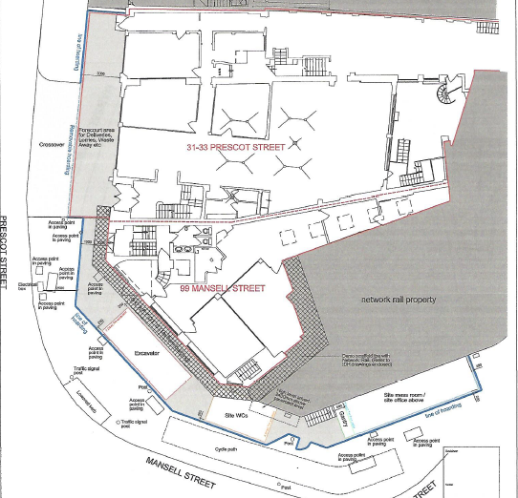

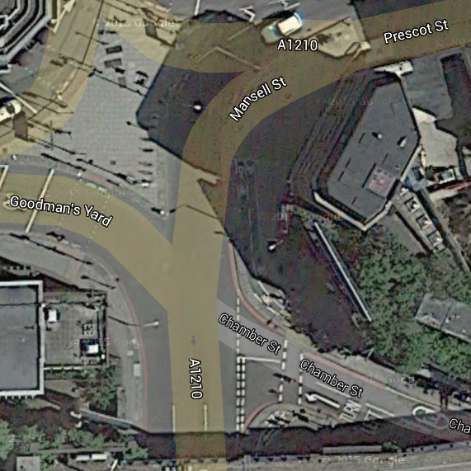Key

Cycle lane closure

Signage advising closure

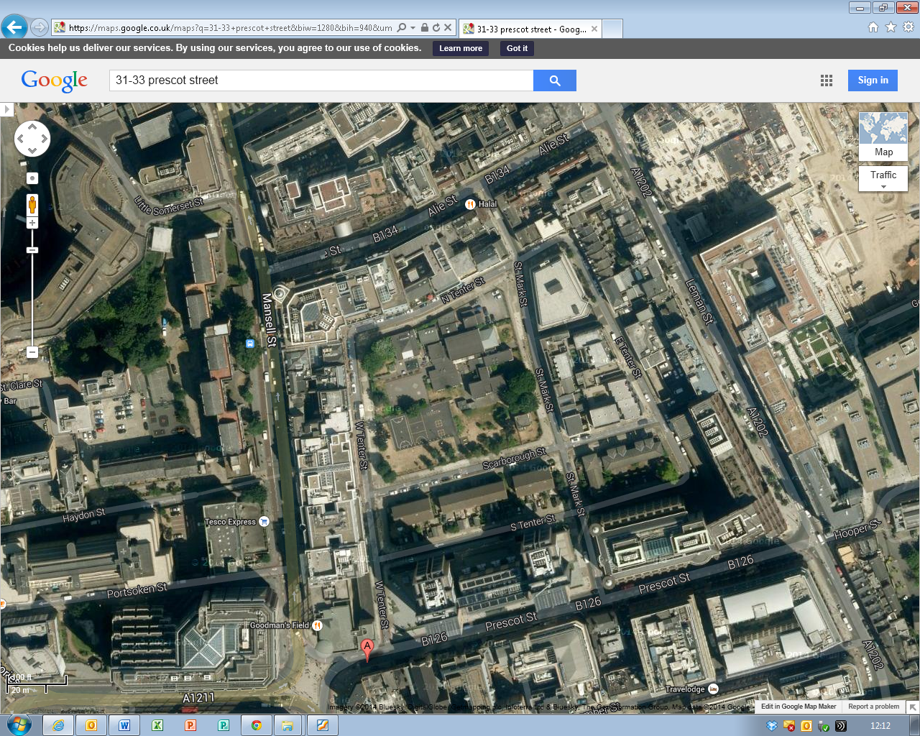

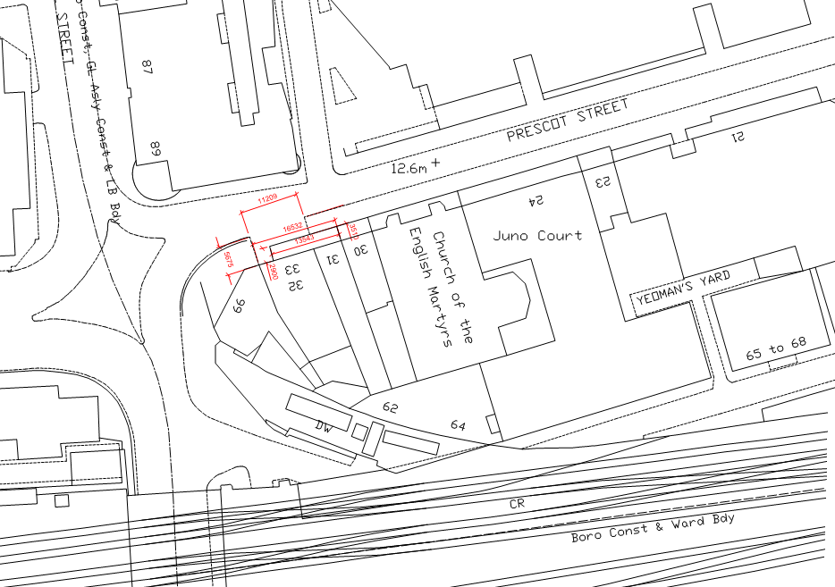**C:\TEMP\Temporary Internet Files\Content.IE5\8EG6ANP7\MC900435238[1].pngC:\TEMP\Temporary Internet Files\Content.IE5\CRCR11BD\MC900334664[1].wmfC:\TEMP\Temporary Internet Files\Content.IE5\8EG6ANP7\MC900435238[1].pngC:\TEMP\Temporary Internet Files\Content.IE5\8EG6ANP7\MC900435238[1].pngC:\TEMP\Temporary Internet Files\Content.IE5\8EG6ANP7\MC900435238[1].png[https://encrypted-tbn2.gstatic.com/images?q=tbn:ANd9GcQSl-9B3BFgkuYj1kxMPcKyoU9ljxCE8WWD_VJvnCNwBHbKWGqj](http://www.google.co.uk/url?sa=i&rct=j&q=&esrc=s&frm=1&source=images&cd=&cad=rja&docid=e6sshJGhHXXa-M&tbnid=bld-p79SZZvLOM:&ved=0CAUQjRw&url=http://www.clker.com/clipart-black-person-symbol.html&ei=6wH-Uq-TOu-20QXJq4HwDw&bvm=bv.61190604,d.ZG4&psig=AFQjCNGEMWYS-ta-pUwxHqtJDg-QTo3c3Q&ust=1392464735623271)[https://encrypted-tbn3.gstatic.com/images?q=tbn:ANd9GcTdyg01IFoP0Ox5LT3jYxNocMeW1AMaf32T6RdeCBshEe8kIFKr](http://www.google.co.uk/url?sa=t&rct=j&q=&esrc=s&frm=1&source=images&cd=&ved=0CAQQjRw&url=http://www.ebay.co.uk/bhp/pedestrian-safety-barriers&ei=Lv_9UufRLMuVhQe8v4HoDg&usg=AFQjCNFytYgsViLYLIScvrehXDRycXQuZA&bvm=bv.61190604,d.ZG4)[https://encrypted-tbn2.gstatic.com/images?q=tbn:ANd9GcQSl-9B3BFgkuYj1kxMPcKyoU9ljxCE8WWD_VJvnCNwBHbKWGqj](http://www.google.co.uk/url?sa=i&rct=j&q=&esrc=s&frm=1&source=images&cd=&cad=rja&docid=e6sshJGhHXXa-M&tbnid=bld-p79SZZvLOM:&ved=0CAUQjRw&url=http://www.clker.com/clipart-black-person-symbol.html&ei=6wH-Uq-TOu-20QXJq4HwDw&bvm=bv.61190604,d.ZG4&psig=AFQjCNGEMWYS-ta-pUwxHqtJDg-QTo3c3Q&ust=1392464735623271)[https://encrypted-tbn3.gstatic.com/images?q=tbn:ANd9GcTdyg01IFoP0Ox5LT3jYxNocMeW1AMaf32T6RdeCBshEe8kIFKr](http://www.google.co.uk/url?sa=t&rct=j&q=&esrc=s&frm=1&source=images&cd=&ved=0CAQQjRw&url=http://www.ebay.co.uk/bhp/pedestrian-safety-barriers&ei=Lv_9UufRLMuVhQe8v4HoDg&usg=AFQjCNFytYgsViLYLIScvrehXDRycXQuZA&bvm=bv.61190604,d.ZG4)C:\TEMP\Temporary Internet Files\Content.IE5\CRCR11BD\MC900334664[1].wmfC:\TEMP\Temporary Internet Files\Content.Word\7031.jpg[https://encrypted-tbn2.gstatic.com/images?q=tbn:ANd9GcQSl-9B3BFgkuYj1kxMPcKyoU9ljxCE8WWD_VJvnCNwBHbKWGqj](http://www.google.co.uk/url?sa=i&rct=j&q=&esrc=s&frm=1&source=images&cd=&cad=rja&docid=e6sshJGhHXXa-M&tbnid=bld-p79SZZvLOM:&ved=0CAUQjRw&url=http://www.clker.com/clipart-black-person-symbol.html&ei=6wH-Uq-TOu-20QXJq4HwDw&bvm=bv.61190604,d.ZG4&psig=AFQjCNGEMWYS-ta-pUwxHqtJDg-QTo3c3Q&ust=1392464735623271)**

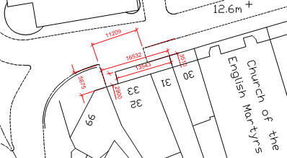

**Key:**

|  |  |  |  |
| --- | --- | --- | --- |
|  | Skip Location/Site Loading bay |  | Site |
|  | Delivery/Removal Route | C:\TEMP\Temporary Internet Files\Content.Word\7031.jpg | Stop Work Sign |
| [https://encrypted-tbn3.gstatic.com/images?q=tbn:ANd9GcTdyg01IFoP0Ox5LT3jYxNocMeW1AMaf32T6RdeCBshEe8kIFKr](http://www.google.co.uk/url?sa=t&rct=j&q=&esrc=s&frm=1&source=images&cd=&ved=0CAQQjRw&url=http://www.ebay.co.uk/bhp/pedestrian-safety-barriers&ei=Lv_9UufRLMuVhQe8v4HoDg&usg=AFQjCNFytYgsViLYLIScvrehXDRycXQuZA&bvm=bv.61190604,d.ZG4) | Pedestrian Barrier | [https://encrypted-tbn2.gstatic.com/images?q=tbn:ANd9GcQSl-9B3BFgkuYj1kxMPcKyoU9ljxCE8WWD_VJvnCNwBHbKWGqj](http://www.google.co.uk/url?sa=i&rct=j&q=&esrc=s&frm=1&source=images&cd=&cad=rja&docid=e6sshJGhHXXa-M&tbnid=bld-p79SZZvLOM:&ved=0CAUQjRw&url=http://www.clker.com/clipart-black-person-symbol.html&ei=6wH-Uq-TOu-20QXJq4HwDw&bvm=bv.61190604,d.ZG4&psig=AFQjCNGEMWYS-ta-pUwxHqtJDg-QTo3c3Q&ust=1392464735623271) | Trained Banksman/Traffic Marshal |
|  | Existing Crossover | C:\TEMP\Temporary Internet Files\Content.IE5\CRCR11BD\MC900334664[1].wmf | Pedestrian Crossing |

**Note:**

Prescot Street is a one way dual carriageway and is also a red route; there are also traffic lights at the junction with Minories and Mansell Street which leads to a back log of traffic to the front of the site. Delivery drivers and suppliers are not to stop along this road on the red route and are to pull into the identified delivery area under the control of the traffic marshal; therefore drivers are to make contact with site management to advise time of arrival in order that arrangements can be implemented.

